CORRECTION subject 2

华东理工大学2022–2023学年第一学期

East China University of Science and Technology,

2022–2023 school year, first semester

《***************************》Final Exam A / B 2022.12

开课学院/School：国卓学院，专业/Major：化工与制药

考试形式/ Exam format： ，所需时间/ Time required： 90 分钟/ Minutes

考生姓名/Name： 学号/Student ID： 班级/Class：

任课老师/Teacher ：CERNEAUX Sophie

|  |  |  |  |  |  |  |  |
| --- | --- | --- | --- | --- | --- | --- | --- |
| 题序/ Number of sections | 1 | 2 | 3 | 4 | 5 | 6 | 总 分Total point number |
| 得分/Points per section | 50 | 50 |  |  |  |  | 100 |
| 评卷人/Responsible teacher |  | | | | | |  |

Documents are not allowed during the exam.

The duration of the exam is 90 minutes.

**Section 1. Study of the Pavonite AgBi3S5. (50 points)**

1) *(2 points)* C, Z =2

2) face centered body, translations of ½(a+b) *(4 points)*

3) class of symmetry 2/m and monoclinic system *(4 points)*

4) *(20 points)*

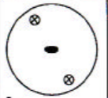

5) *(20 points)*

**Symmetry elements:**

* **2: 2-fold rotation axis parallel to (Oz). Rotation of pi around z.**
* **1: identity**
* **-1: inversion center**
* **m: mirror that is perpendicular to the (Oz) axis, or // to the plane (xOy). We have a mirror reflection through the (xOy) plane.**

**Section 2. Study of La2CO5. (50 points)**

1) lattice mode A, Z=2 *(2 points)*

2) base centered body, translations of ½(b+c) *(4 points)*

3) class of symmetry mm2, orthorhombic system *(4 points)*

4) *(8 points)* **2dhkl sin Ɵ = λ**

**Donc d020=1,5406/2sin6,5=3,5808 Å**

**D011 = 3,8637 A**

**D031 = 2,9762 A**

5) Dessinez les plans (020), (011) et (031) dans un repère orthonormé ainsi que les rangées [120], [011] et [-112]. *(12 points)*

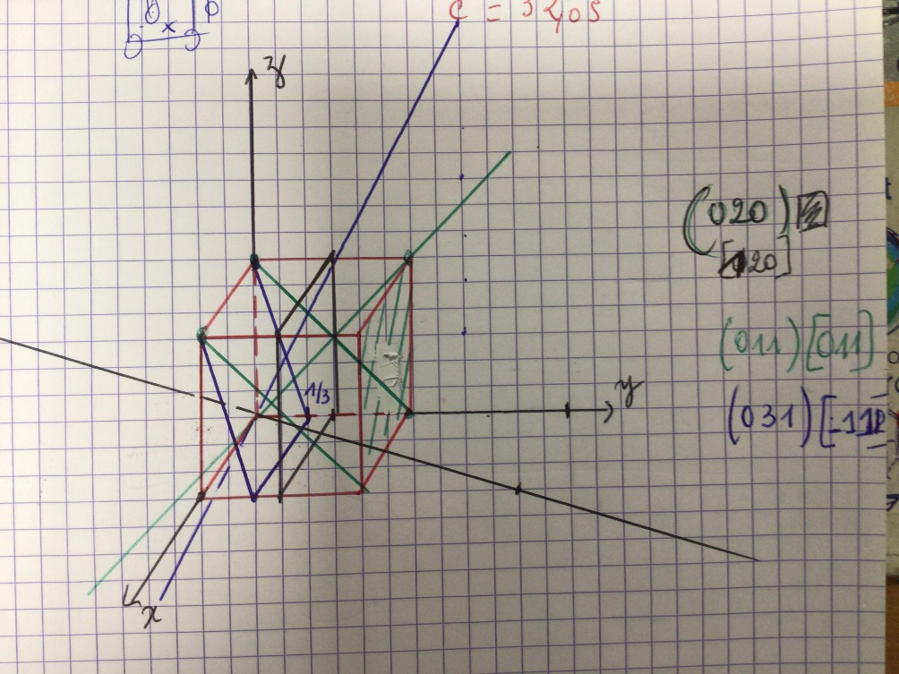

6) Définissez de façon la plus détaillée possible les différents éléments de symétrie du groupe d’espace **A m a 2**. Indiquez leur nature, expliquez les opérations générées et donnez leur position par rapport aux axes cristallographiques. *(20 points)*

**Symmetry elements :**

* **m : mirror perpendicular to (Ox), or // to (zOy). We have a mirror reflection through the (zOy) plane.**
* **a: glide mirror of type a that is perpendicular to (Oy), or // to the plane (xOz). We have a mirror reflection through the (xOz) plane and a translation of ½ of a in the direction // to y.**
* **2: 2-fold rotation axis parallel to (Oz). Rotation of pi around z.**
* **1 : identity**